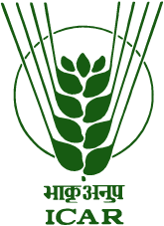
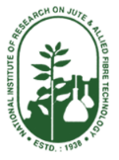
भाकृअनुप-राष्‍ट्रीय प्राकृतिक रेशा अभियांत्रिकी एवं प्रौद्योगिकी संस्‍थान
ICAR-NATIONAL INSTITUTE OF NATURAL FIBRE ENGINEERING AND TECHNOLOGY
12, रीजेंट पार्क, कोलकाता – 700 040, 12, Regent Park, Kolkata - 700 040.
: +91-33-2471-4812;: +91-33-2471-2583;
:director.nirjaft@icar.gov.in; nirjaft.scu@gmail.com: www.nirjaft.res.in

Application for permission to act as an external examiner/ expert/ moderator etc.

Name of the applicant :
Examination :
Duration of examination : From ……………………………… to ………………………………
University/ Board/ Institute :

Date Signature

N.B.
- A copy of the invitation letter should be enclosed.
- The application should be sent at least 7 days before the date of examination.

